AMERICAN UNIVERSITY STAT 614 **HOMEWORK 2** CHAPTERS 1 and 2

Please read and study all of Chapter 1 of your text and the first **2 sections** of Chapter 2. You are to type the answers for the problems below.

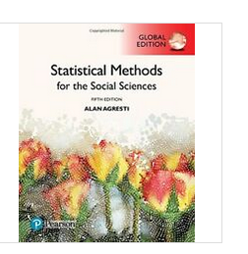

#1 Page 20 Problem 1.2

#2 Page 21 Problem 1.6

#3 Page 21 Problem 1.8

#4 Page 22 Problem 1.16

#5 Page 37 Problem 2.6

#6 Page 38 Problems 2.14a and 2.14b